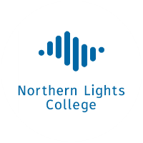**Certificate of Completion**

**First Name Last Name**

**has successfully completed the**

**British Columbia Working in Natural Gas   
Entry Level Training Program**

**Given on this day of 20­**

President, Northern Lights College

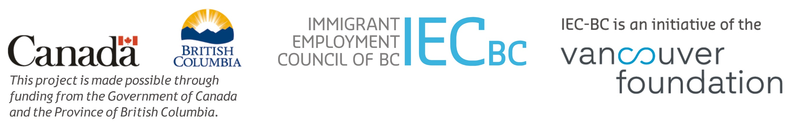

***Ministry of Social Development and Poverty Reduction***

***Ministry of Advanced Education, Skills & Training***

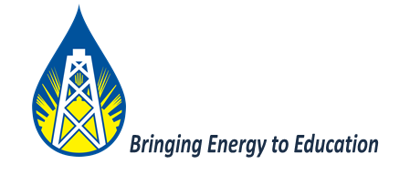

**BC Centre of Training Excellence in Oil and Gas**